Rutgers Business School
33:136:370 Management Information Systems
Instructor: Disha Parkhi
Following are the examples for Many to many relationships (From Chapter 7)

7.1 Tour operator: You manage a tour company that operates tours of local historical and natural attractions. You have several dozen different tour packages, each with a name (such as “Exploring Native Ruins” or “Bird‐ Watching Hike”), a scheduled duration in minutes, a per‐guest price, and a maximum number of guests. You also have a staff of dozens of guides, for each of which you want to store a first name, middle initial, last name, and date hired. For each guest who has ever taken or has booked a reservation to take one of your tours, you want to store a first name, middle initial, last name, gender, date of birth, and mobile phone number. You group guests into households, for each of which you want to store address information (street address, city, state, and zip code), and a primary credit
card number. Assume that you have access to a national zip code table that you wish to include in your database design, and that each guest can be a member of only one household. A tour consists of one of your guides taking a group of guests on one of the tour packages. For each tour, you want your system to remember what tour package it was, which guide conducted it, and which guests participated. You also want to store a scheduled start date and time, and an actual completion time (blank for tours that are in the future). Over time, guests can participate in more than one tour. Draw an ER diagram‚ and write a database design outline for a database appropriate for this information.

Solution:

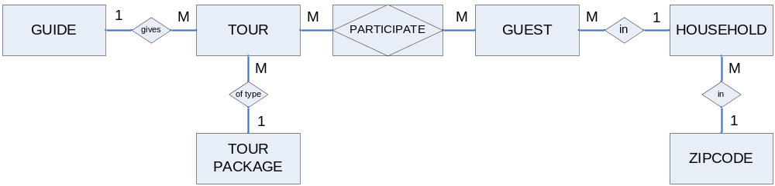

GUIDE(GuideID, FirstName, MiddleInit, LastName, DateHired)
TOURPACKAGE(PackageID, Name, ScheduledMinutes, PerGuestPrice, MaxGuests)
ZIPCODE(Zip, City, State)
HOUSEHOLD(HouseholdID, Address, Zip, PrimaryCreditCard)
Zip foreign key to ZIPCODE
GUEST(GuestID, FirstName, MiddleInit, LastName, Gender, DateOfBirth, MobilePhone, HouseholdID)
HouseholdID foreign key to HOUSEHOLD
TOUR(TourID, ScheduledDateTime, ReturnTime, PackageID, PackageID, GuideID)
PackageID foreign key to TOURPACKAGE
GuideID foreign key to GUIDE
PARTICIPATE(GuestID, TourID)
GuestID foreign key to GUEST
TourID foreign key to TOUR
Synthetic keys are the most convenient primary keys for all tables except ZIPCODE, which has the obvious primary key Zip, and the PARTICIPATES table which implements the many-to-many relationship between GUEST and TOUR. This table has the conventional composite key for a many-to-many relationship. Since it is presumably unique, the tour name would be a possible but awkward primary key for TOURPACKAGE. For TOUR, the composite key (Guide, ScheduledDateTime) is possible since a single guide is presumably unable to lead two tours at the same time. However, this choice would require an inconvenient composite foreign key in PARTICIPATES, which would be more complicated than the design shown. The many-to-many relationship between TOUR and GUEST could instead be depicted as two one-to-many relationships.
7.2 Compatibility of auto parts: Zip Guys, Inc., runs a large network of auto part stores. Each part they offer for sale is identified by an SKU code assigned by Zip Guys. For each part, they want to store the part manufacturer name, a manufacturer’s part number, a unit price, and the associated part type; each part has only one type. Part types are identified by a code, along with a description: for example “FUELFILT” for “fuel filter” or “SIGLAMP” for “signaling lamp.” A critical function of Zip Guys’ database is to identify the compatibility of each part with each type of vehicle. Each type of vehicle is identified by a specific “vehicle type code” that corresponds to a specific combination of vehicle make, model name, year, and engine description (such as “2.8 liter V6”). Usually, a given part fits more than one vehicle type, and there are, of course, a large variety of parts that can fit any given vehicle. The database needs to be organized so that when a customer has a request such as “I need a tail light bulb for a 2008 Toyota Matrix,” the store staff can query the database to find out which appropriate part(s) the store sells will fit the customer’s vehicle. Your database should also contain a table of known vehicle makes (but, for simplicity, do not include separate tables for known model names and engine types). Design a database for this information, creating an ER diagram and a database design outline.

MAKE(Make)
VEHICLETYPE(VehicleTypeID, Make, Model, Year, Engine)
Make foreign key to MAKE
PARTTYPE(PartTypeCode, Description)
PART(SKU, ManufacturerName, ManufacturerPartNumber, UnitPrice, PartTypeCode)
PartTypeCode foreign key to PARTTYPE
FITS(SKU, VehicleTypeID)
SKU foreign key to PART
VehicleTypeID foreign key to VEHICLETYPE
Note that we could also create a synthetic key for the MAKE table, in which case the first two tables would take the form
MAKE(VehicleMakeID, Make)
VEHICLETYPE(VehicleTypeID, VehicleMakeID, Model, Year, Engine)
VehicleMakeID foreign key to MAKE
However, most vehicle make names are not terribly long and they ought to be unique, so the make itself could probably serve as a primary key for the MAKE table. We could also add tables to list the valid combinations of makes and models, but the instructions asked you to avoid such complexities.

One could instead depict the many-to-many relationship between VEHICLETYPE and PART as two one-to-many relationships.

